|  |
| --- |
|  |



**5 April 2013** **The Weekly Bulletin of Rotary Club of Kathmandu Mid-Town** **Bc-5.4/012-13**

**District : 3292 Web: www.rotarymidtown.org.np Club Id : 26776**

**APRIL IS MAGAZINE MONTH**

**Rotary International today claims a unique communications network — The Rotarian, the official English language magazine of Rotary International and 31 Rotary World Magazine Press magazines that are independently produced in their countries across the globe. They are published in more than 20 different languages, distributed in 132 countries, and have a combined circulation of 769,000.**

Friday, 8 March:



Guest Speaker, Dr Jeevan L Amatya, a veterinary doctor by profession provided a very

useful notes on uses and effects/benefits from health point of views, of various spices and

dried fruits such as mustard seeds, cloves, garlic, asafoetida, turmeric, cinnamon, cumin,

nutmeg, and coriander.

Friday, 15 March:

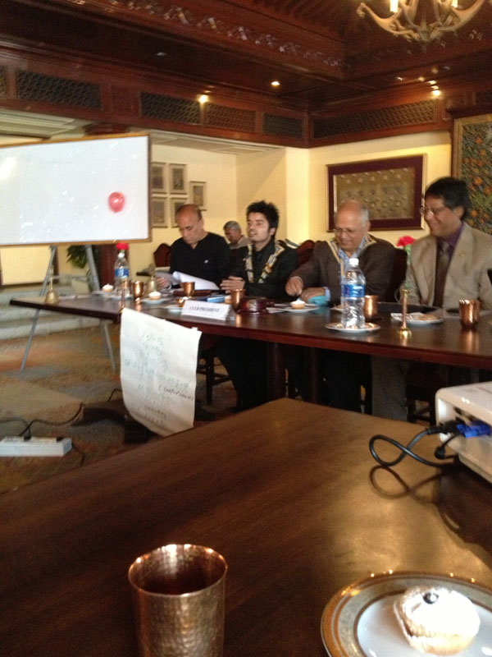

Rtr Kishore Acharya, President of Rotaract Club of Kathmandu Mid-Town,

presented the activities of the Rtr club with great enthusiasm and

confidence. The club has been able to make this year a special with

various new initiations like a campaign of eye screening of more than

10,000 school children, provision of prosthetic arms to 60 needy people,

joint International skype meeting, token of love being presented to RIP

and being able to create international project where the club facilitate

and encourage other clubs from different district to participate.

The club has been recognized by MDIO for Extensive Free Eye Camp

and by RI for being one of the three winners in Interact Video

Competition. Behind all this success story, he emphasized, that there was the hand of *guruma* Rtn. Lekha, various Rotarians, Parent club, Rotaract members and guests.

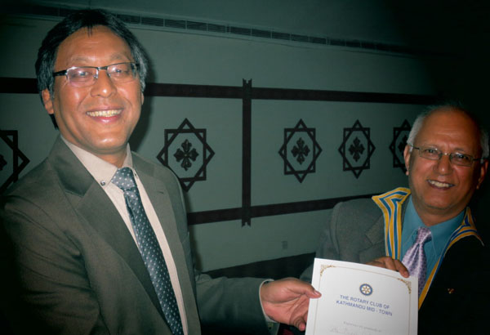

Friday, 22 March (Dinner meeting):

The regular breakfast meeting of the Club was re-scheduled as

dinner meeting on the same day evening at the regular venue, i.e.,

Hotel Annapurna, Durbarmarg with a view of giving farewell to

Rtn. Buddha, Club Secretary 2012-13, who was scheduled to

return to India on 25 March after completing his assignment tenure

in Surya Nepal. Rtn Buddha talked about his professional

experiences in Nepal and appreciated cooperation he received from

all corners. He shared his happiness for being involved in the Club

and working together with Mid-Towners in whatever little way and

possible times during his stay in Nepal. He also provided a brief presentation on various slides of his involvement in Rotary and Rotaract club activities. His experience on Bipasyana was one of the most valuable and it did inspire him to plan for establishment of a Bipashyana center in Shillong India. He expressed his happiness to be a part of RC Kathmandu Mid-Town.

Friday, 29 March :

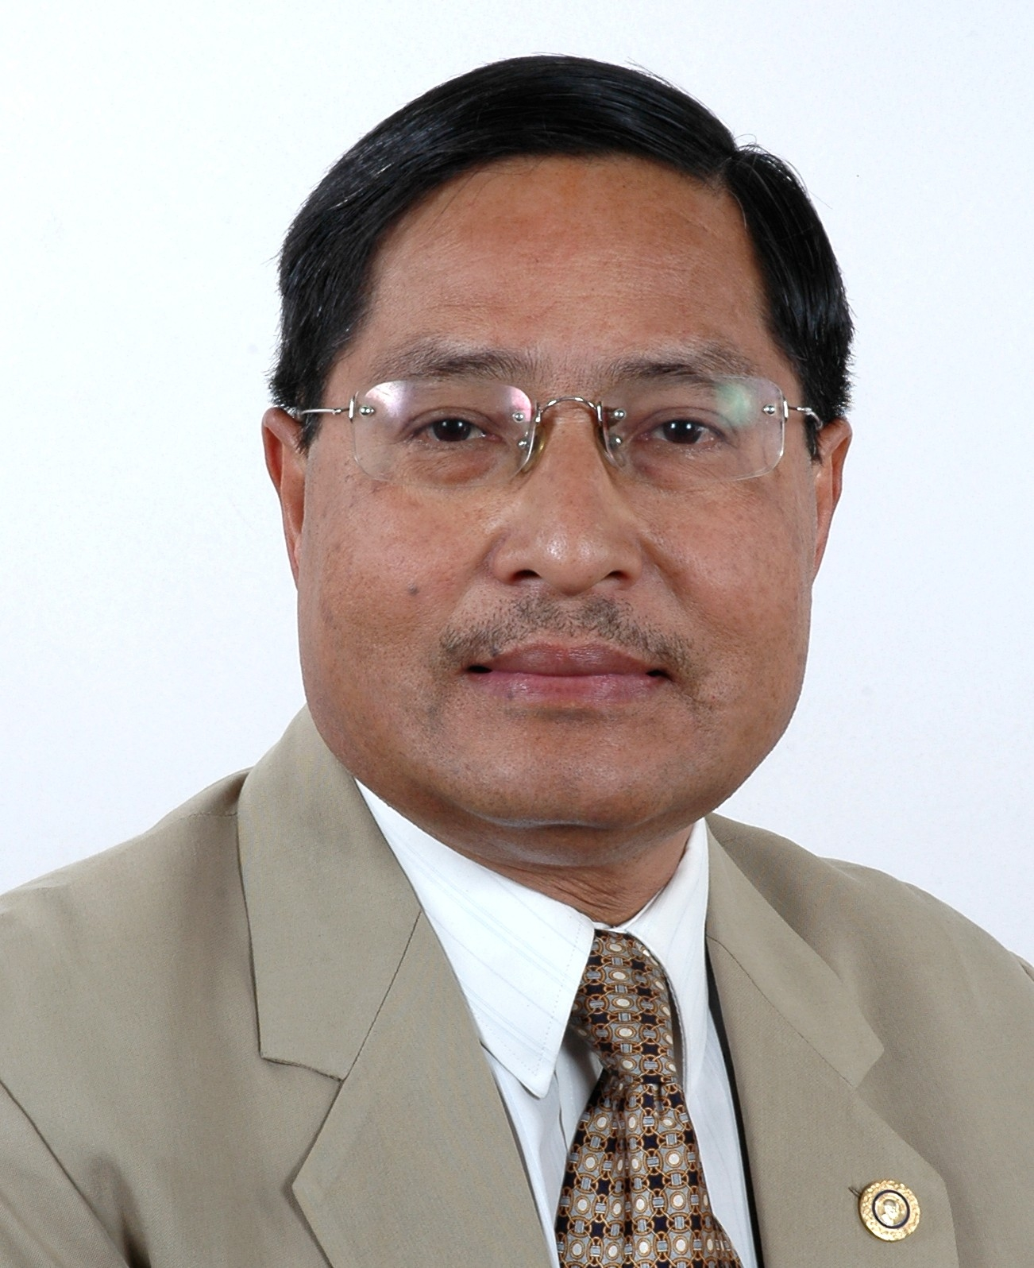

Rtn MB Shrestha, PP of Rotary Club of Kopundol, and District Publication (GML) Sub-

committee Chair (2012-13), was our Guest Speaker for the day. He presented a very

interesting 'Photo Journey to Everest Base Camp' and his reflections on the trip. The

travelogue started from Lukla airport to Namchebazar, Thyangboche, Khumbu glacier

and then to the Everest Base Camp at an altitude of 5,364 meters. This high altitude

trekking exposed the beauty, serenity and divinity of the Himalayan Mountain. Every

moment was a great experience, when Amadablam, Mt. Everest and other peaks were visible in the route.

# Weekly Meetings and Programs :

|  |  |  |
| --- | --- | --- |
| Date | Program/Speaker | Program/Topics of Presentation |
| 5 April 2013 | Rtn. Neeva Pradhan | The 5 H Program with the International Association for Human Values |
|  |  |  |

Friday, 5 April:

In-house Speaker Rtn Neeva Pradhan, who is in the town currently, will give a talk on “The 5 H Program with the International Association For Human Values".

The 5H's program focuses on ***Human Values, Health, Hygiene, Homes, Harmony in Diversity.***

The overall objective of the Program is to promote healing and restore harmony in society. It also deals with community enhancement, women empowerment, education, hygiene, organic farming and more.

The nonprofit program is backed by the United Nations and the WHO and is a social organization present in 150 countries across the globe.

**'Service Above Self' Award to Rtn Ambica**

**Congratulations** **to**

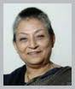

**Rtn** **Ambica Shrestha**

The Rotary International Highest Award ***‘Service Above Self'*** was handed over to PP Ambica Shrestha by RI President's Representative Rtn PT Prabhakar at the 5th District Conference.

**District Governor Nominee for RY 2015-16:**

***Congratulations*** **to**

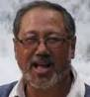

**Rtn Rajesh Thapa**

The Nominating Committee formed recently for nominating District Governor for RY 2015-16 nominated Rtn Rajesh Thapa from among the three candidates nominated from three Rotary Clubs. The other two candidates were Rtn Keshav Kunwar and Rtn Jaya Shah.

**District Conference:**

The 5th District Conference was held as scheduled on 16th-18th March 2013 in Kathmandu, venue – Soaltee Crown Plaza Hotel. The theme of the 5th District Conference was “Samarpan” - ” Dedication”.

[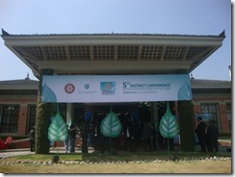](http://technetnepal.net/cfs-file.ashx/__key/CommunityServer.Blogs.Components.WeblogFiles/rotary/DSC03047_5F00_2DF80FB4.jpg) [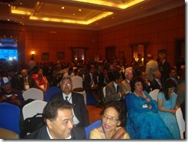](http://technetnepal.net/cfs-file.ashx/__key/CommunityServer.Blogs.Components.WeblogFiles/rotary/DSC03063_5F00_57229F40.jpg)

The theme was symbolized by the Peepal Leaf: Nepalese tradition, norms and values teaches us to offer as much as we do to other living kinds. It symbolizes dedication, purity and humanity.

[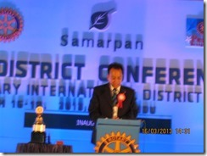](http://technetnepal.net/cfs-file.ashx/__key/CommunityServer.Blogs.Components.WeblogFiles/rotary/IMG_5F00_4117_5F00_3812849A.jpg) [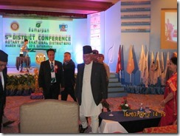](http://technetnepal.net/cfs-file.ashx/__key/CommunityServer.Blogs.Components.WeblogFiles/rotary/IMG_5F00_4114_5F00_1BB86F05.jpg)

District Conference Committee Chair Rtn. Anand Tuladhar giving his Welcome speech - "District Conference is the most significant annual event of the District. A time to regenerate a sense of belongingness to a larger fraternity and to inspire members to re-dedicate themselves to the Rotary cause and the Rotary way."

The Conference was inaugurated by Chief Guest Rt. Hon'ble Paramanand Jha, Vice President of Nepal by lighting Panas.

Rotarians from 76 Clubs participated in the Conference. Altogether 8 Keynote Speakers – Dr Suresh Raj Sharma, PDG Tirtha Man Sakya, Ms Chadani Joshi, Mr Dawa Steven Sherpa, Dr Roop Jyoti, Dr Ram Kantha Makaju Shrestha, Mr Yuva Raj Ghimire and IPDG Basu Dev Golyan provided their presentations on varied subjects/topics – development, family values, community service, peace and development etc.

**Visiting Grande International Hospital, Dhapashi:**

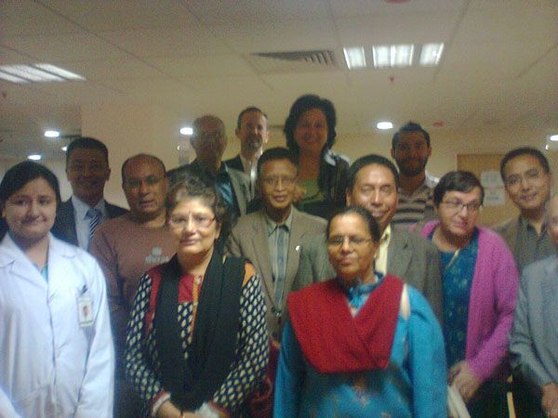

A group of Mid-Towners paid a visit to Grande International Hospital, Dhapashi on Friday morning, 22 March. Thanks to CP Roop Jyoti (Chairman, GIH) for organizing the visit and providing informations on Hospital operation, infrastructure, state-of-the-art service equipment/facilities, services provided and service facilities being installed.

**Committee Chairpersons' Column:**

**???**

**Past Presidents' Column:**

**???**

Focus the energies of your clubs on the three priorities of the RI Strategic Plan: (a) to support

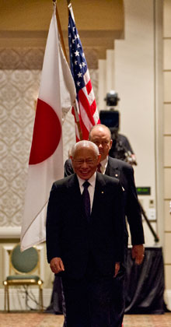

and strengthen clubs, (b) to focus and increase humanitarian service, (c) and to enhance

public image and awareness.

**RI President Sakuji Tanaka**

On Lighter Side :

Click here ⇩



A thought for the day:

***What have you done today for yourself,***

***for the family, for the community, for the nation and for the humanity ?***

Great quotes:

***Negative Thinkers focus on Problems***

***Positive thinkers focus on Solutions !***

Number game:

If 1 ÷ 3 = 0.333333333333….

1 ÷ ? = 0.555555555555….

NB: Send any informations/photos that may be of interest to the Club or Rotarians in general to

BC Editor: RR Shrestha email: rryesrr@gmail.com

## 5 April 2013 The Weekly Bulletin of Rotary Club of Kathmandu Mid-Town bc-5.4/012-13